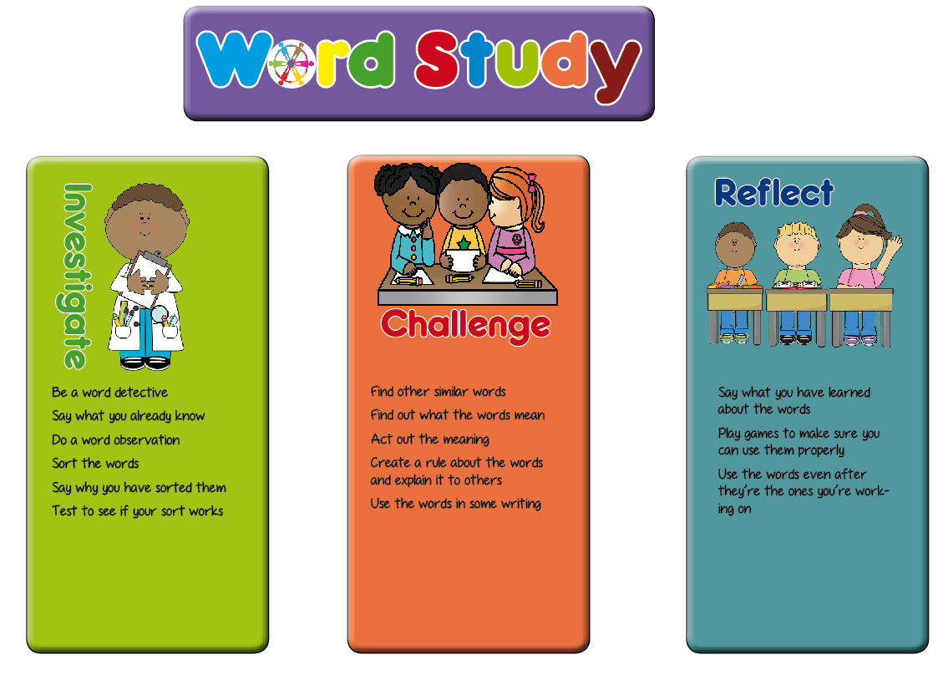**Year 2 Homophone Planning Ideas**

In Key Stage One, we have planned a range of generic activities which fit in with the word study teaching sequence. These are a suggestion for ideas which will generate talk for spelling activities and promote enquiry and discussion of the way words work among the pupils.

Hopefully these ideas will be a springboard for the activities you plan in your classroom.

|  |  |  |
| --- | --- | --- |
| **Investigate** | **Challenge** | **Reflect** |
| Do the sentence sort – either sort by spelling pattern or by use of the word. Get children to discuss what the context of each different spelling use is. Add new sentences to the sorts to test whether the theory they have formed is correct. | * Work in small groups and take it in turns to say sentences with the word in. Children listening have to write on whiteboards the word they think is being used. Peer review their choices, encourage discussion to come to the correct answer. * Find sentences with the words in in reading or class books. * Complete a cloze procedure activity, choosing the right word for the context of each sentence. * Write some sentences with the words in and give them to a peer to check. | * Write a letter or a tweet explaining the rule for when to use each variant of the word * Have cards with the homophones you know on them: pick a card from the pile and write a sentence using the word correctly. Peer mark and discuss. |